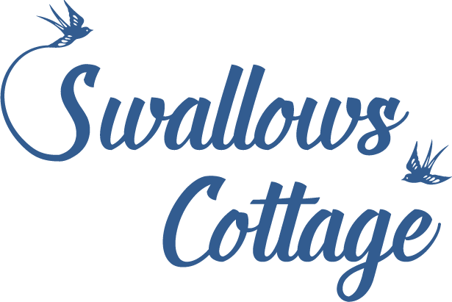
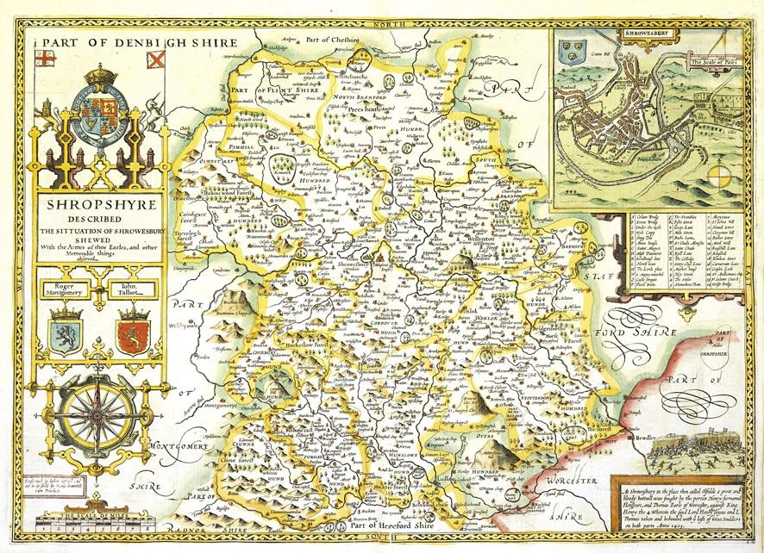

Suggestions for
Places to go and things to do in Shropshire
Visit England | https://www.visitengland.com/things-to-do/shropshire
National Trust | https://www.nationaltrust.org.uk/lists/shropshire
English Heritage | https://www.english-heritage.org.uk/visit/places/#?page=1&place=Shropshire&mp=false&fe=false

Museums
RAF Museum | https://www.rafmuseum.org.uk/cosford/
Ironbridge Museums  Including Blists Hill Victorian Village | https://www.ironbridge.org.uk/
Shrewsbury Museum | http://www.shrewsburymuseum.org.uk/
Acton Scott Victorian Farm - featured in the TV series The Victorian Farm | https://www.actonscott.com/
Severn Valley Railway | https://www.svr.co.uk/
Battlefield Museum and Farm Shop - the site of the Battle of Shrewsbury 1403 | https://www.battlefield1403.com/

Activities
Cycling | http://www.shropshiresgreatoutdoors.co.uk/cycling/
Activity Centre inc archery, quad bikes etc | https://theedgeadventure.co.uk/
Canoe Hire | https://www.canoeuk.com/
Canoe hire, rafting and bike hire | https://www.shropshirerafttours.co.uk/e-bike-and-hybrid-cycle-hire/
Boat Trips - the Sabrina offers a trip on the river around Shrewsbury. Commentry and refreshments are available. | https://www.sabrinaboat.co.uk/day-trips/
Horse Riding | http://www.millfarmridingcentre.co.uk/
Fishing - membership of the Leighton Angling Club is required | http://www.leightonangling.co.uk/blog/

